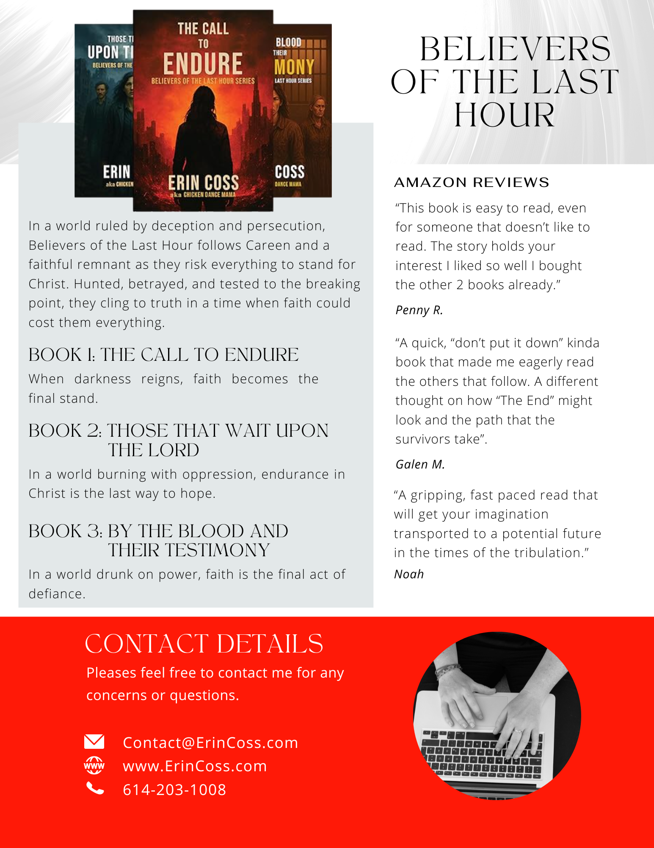

No frills. A little rough around the edges.
But built for copy-and-paste ease.

Erin Coss
Christian Author, Bible Teacher & Speaker
Email: Contact@ErinCoss.com
Phone: 614-203-1008

Believers of the Last Hour Series
In a world ruled by deception and persecution, Believers of the Last Hour follows Careen and a faithful remnant as they risk everything to stand for Christ. Hunted, betrayed, and tested to the breaking point, they cling to truth in a time when faith could cost them everything.

- Book 1: The Call to Endure
When darkness reigns, faith becomes the final stand.
- Book 2: Those That Wait Upon the Lord
In a world burning with oppression, endurance in Christ is the last way to hope.
- Book 3: By the Blood and Their Testimony
In a world drunk on power, faith is the final act of defiance.

Amazon Reviews
“This book is easy to read, even for someone that doesn’t like to read. The story holds your interest I liked so well I bought the other 2 books already.”
Penny R.

“A quick, “don’t put it down” kinda book that made me eagerly read the others that follow. A different thought on how “The End” might look and the path that the survivors take”.
Galen M.

“A gripping, fast paced read that will get your imagination transported to a potential future in the times of the tribulation.”
Noah

URL for Trilogy Photo: Believers of the Last Hour
https://erincoss.com/wp-content/uploads/2025/07/Trilogy-transparent.png

URL for ErinCoss Website
https://erincoss.com/

