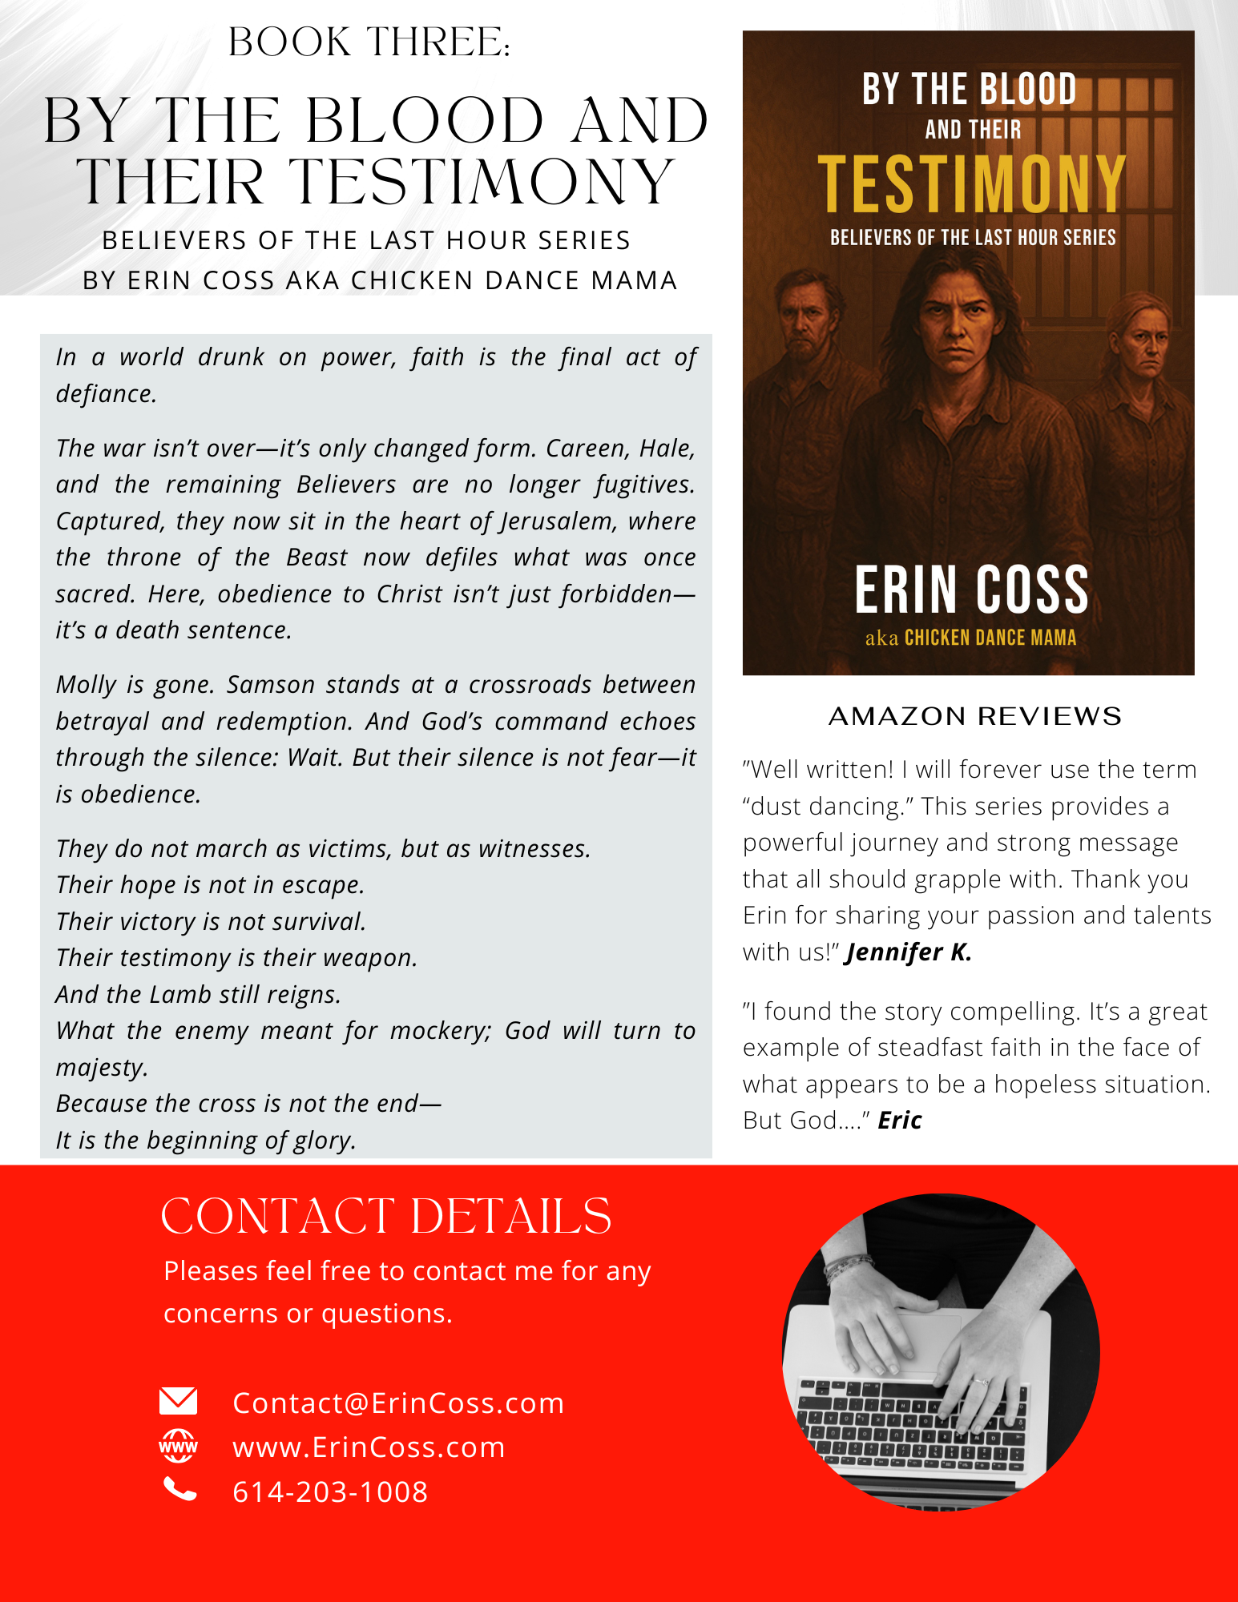

No bells, no whistles—just copy, paste, and go.

Erin Coss
Christian Author, Bible Teacher & Speaker
Email: Contact@ErinCoss.com|
Phone: 614-203-1008

Book 3: By the Blood and Their Testimony
Believers of the Last Hour
By Erin Coss aka The Chicken Dance Mama
In a world drunk on power, faith is the final act of defiance.
The war isn’t over—it’s only changed form. Careen, Hale, and the remaining Believers are no longer fugitives. Captured, they now sit in the heart of Jerusalem, where the throne of the Beast now defiles what was once sacred. Here, obedience to Christ isn’t just forbidden—it’s a death sentence.
Molly is gone. Samson stands at a crossroads between betrayal and redemption. And God’s command echoes through the silence: Wait. But their silence is not fear—it is obedience.
They do not march as victims, but as witnesses.
Their hope is not in escape.
Their victory is not survival.
Their testimony is their weapon.
And the Lamb still reigns.
What the enemy meant for mockery; God will turn to majesty.
Because the cross is not the end—
It is the beginning of glory.

Amazon Reviews
“Well written! I will forever use the term “dust dancing.” This series provides a powerful journey and strong message that all should grapple with. Thank you Erin for sharing your passion and talents with us!” Jennifer K.
“I found the story compelling. It’s a great example of steadfast faith in the face of what appears to be a hopeless situation. But God….” Eric

URL for Book Cover Photo: By the Blood and Their Testimony
https://erincoss.com/wp-content/uploads/2025/06/Book-3-cover-website.jpg

URL for ErinCoss Website
https://erincoss.com/

