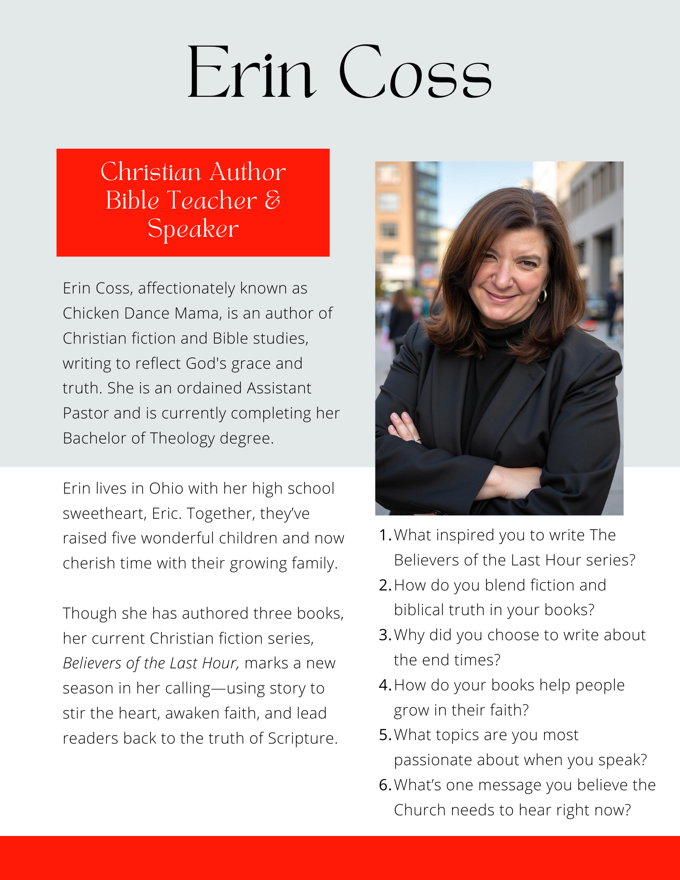

It ain’t pretty—but it’s no-frills and grab-and-go.
Copy and paste away!

Erin Coss
Christian Author, Bible Teacher & Speaker
Email: Contact@ErinCoss.com|
Phone: 614-203-1008

Bio:
Erin Coss, affectionately known as Chicken Dance Mama, is an author of Christian fiction and Bible studies, writing to reflect God's grace and truth. She is an ordained Assistant Pastor and is currently completing her Bachelor of Theology degree.
Erin lives in Ohio with her high school sweetheart, Eric. Together, they’ve raised five wonderful children and now cherish time with their growing family.
Though she has authored three books, her current Christian fiction series, Believers of the Last Hour, marks a new season in her calling—using story to stir the heart, awaken faith, and lead readers back to the truth of Scripture.

Questions:
- What inspired you to write The Believers of the Last Hour series?
- How do you blend fiction and biblical truth in your books?
- Why did you choose to write about the end times?
- How do your books help people grow in their faith?
- What topics are you most passionate about when you speak?
- What’s one message you believe the Church needs to hear right now?
URL for Erin Coss Head Shot
https://erincoss.com/wp-content/uploads/2025/07/Erin-Coss-Headshot-1.jpg

URL Erin Coss Website
https://erincoss.com/

