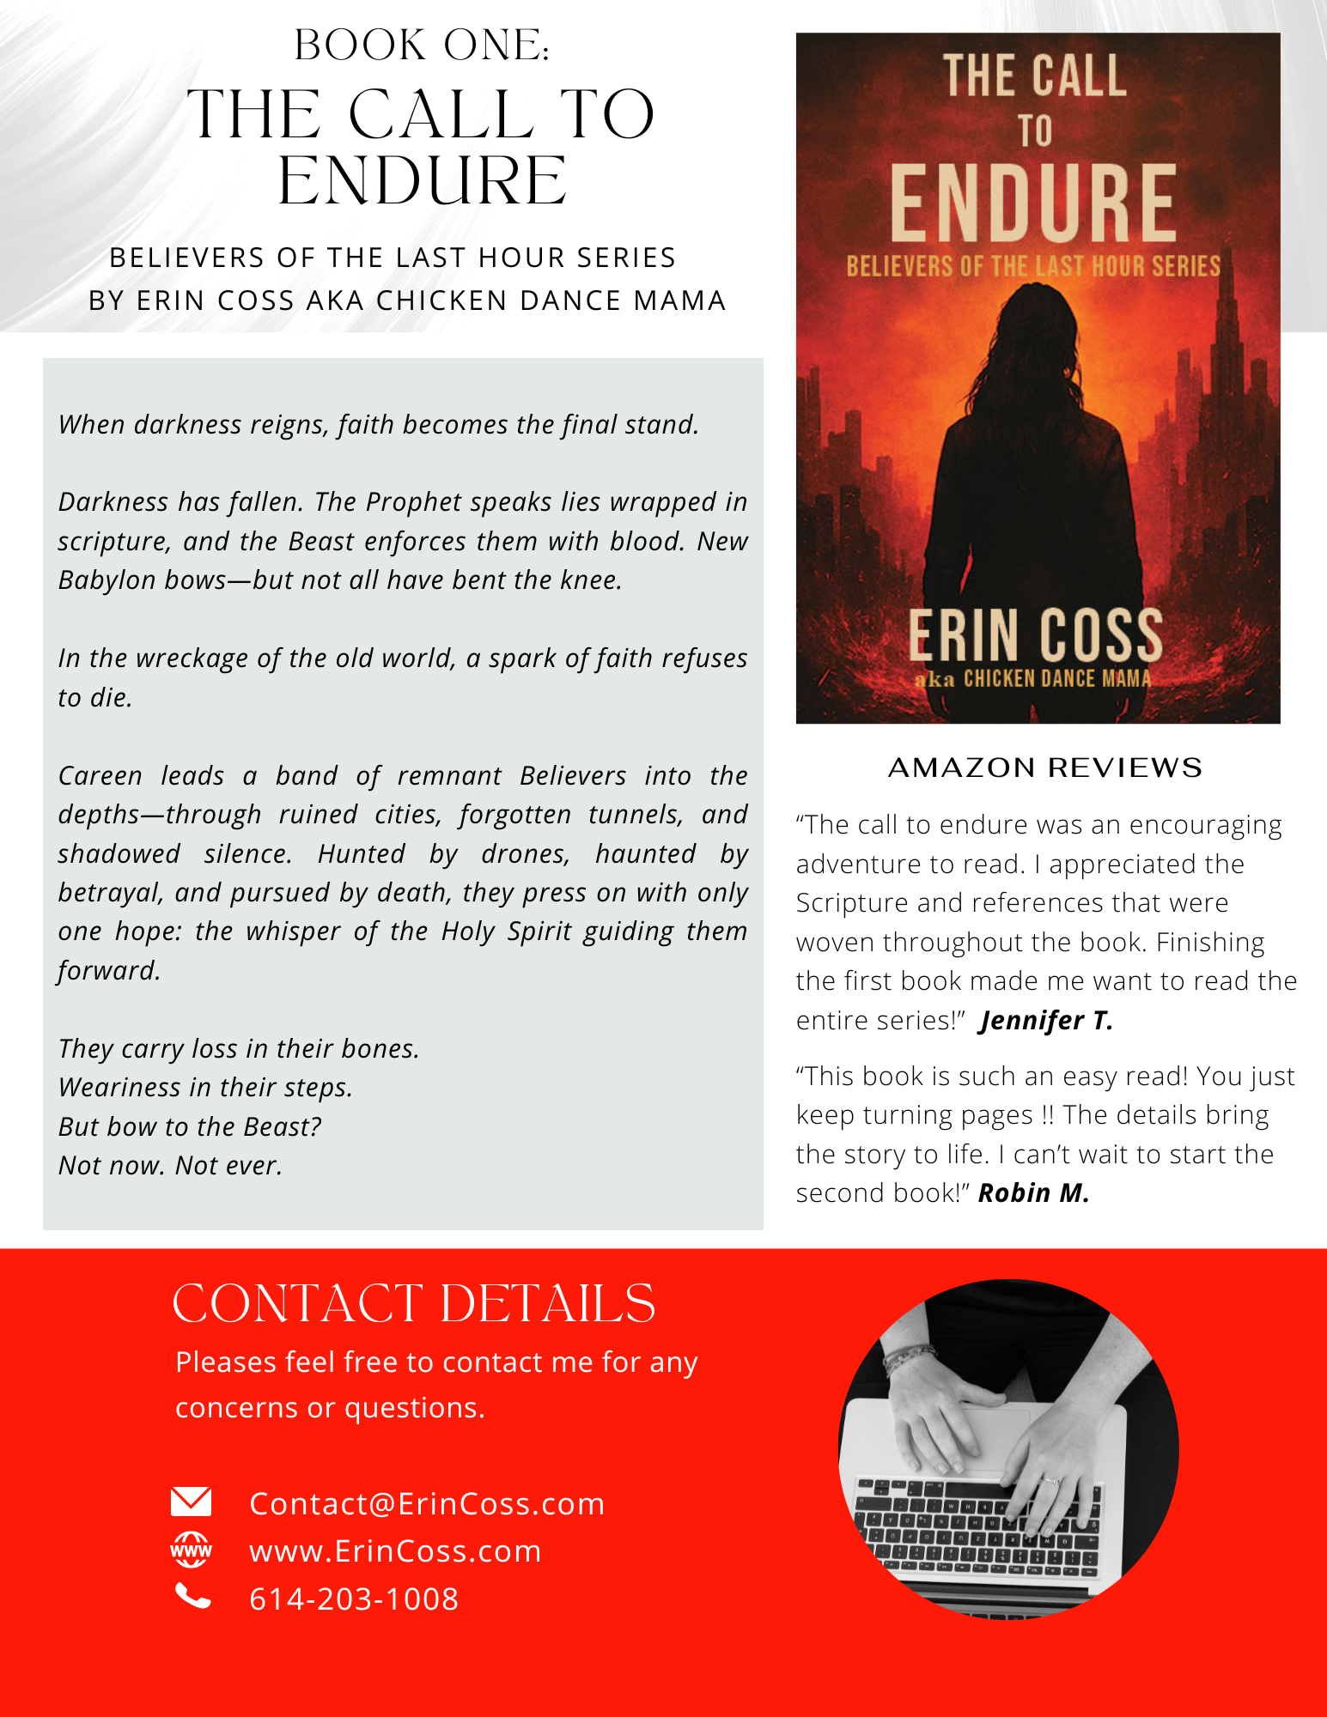

Not fancy. Not fussy.
It’s just easy to copy and paste.

Erin Coss
Christian Author, Bible Teacher & Speaker
Email: Contact@ErinCoss.com
Phone: 614-203-1008

Book 1: The Call to Endure
Believers of the Last Hour
By Erin Coss aka The Chicken Dance Mama
When darkness reigns, faith becomes the final stand.
Darkness has fallen. The Prophet speaks lies wrapped in scripture, and the Beast enforces them with blood. New Babylon bows—but not all have bent the knee.
In the wreckage of the old world, a spark of faith refuses to die.
Careen leads a band of remnant Believers into the depths—through ruined cities, forgotten tunnels, and shadowed silence. Hunted by drones, haunted by betrayal, and pursued by death, they press on with only one hope: the whisper of the Holy Spirit guiding them forward.
They carry loss in their bones.
Weariness in their steps.
But bow to the Beast?
Not now. Not ever.

Amazon Reviews
“The call to endure was an encouraging adventure to read. I appreciated the Scripture and references that were woven throughout the book. Finishing the first book made me want to read the entire series!”
Jennifer T.
“This book is such an easy read! You just keep turning pages !! The details bring the story to life. I can’t wait to start the second book!”
Robin M.

URL for Book Cover Photo: The Call to Endure
https://erincoss.com/wp-content/uploads/2025/06/Book-1-cover-website.jpg

URL for ErinCoss Website
https://erincoss.com/

