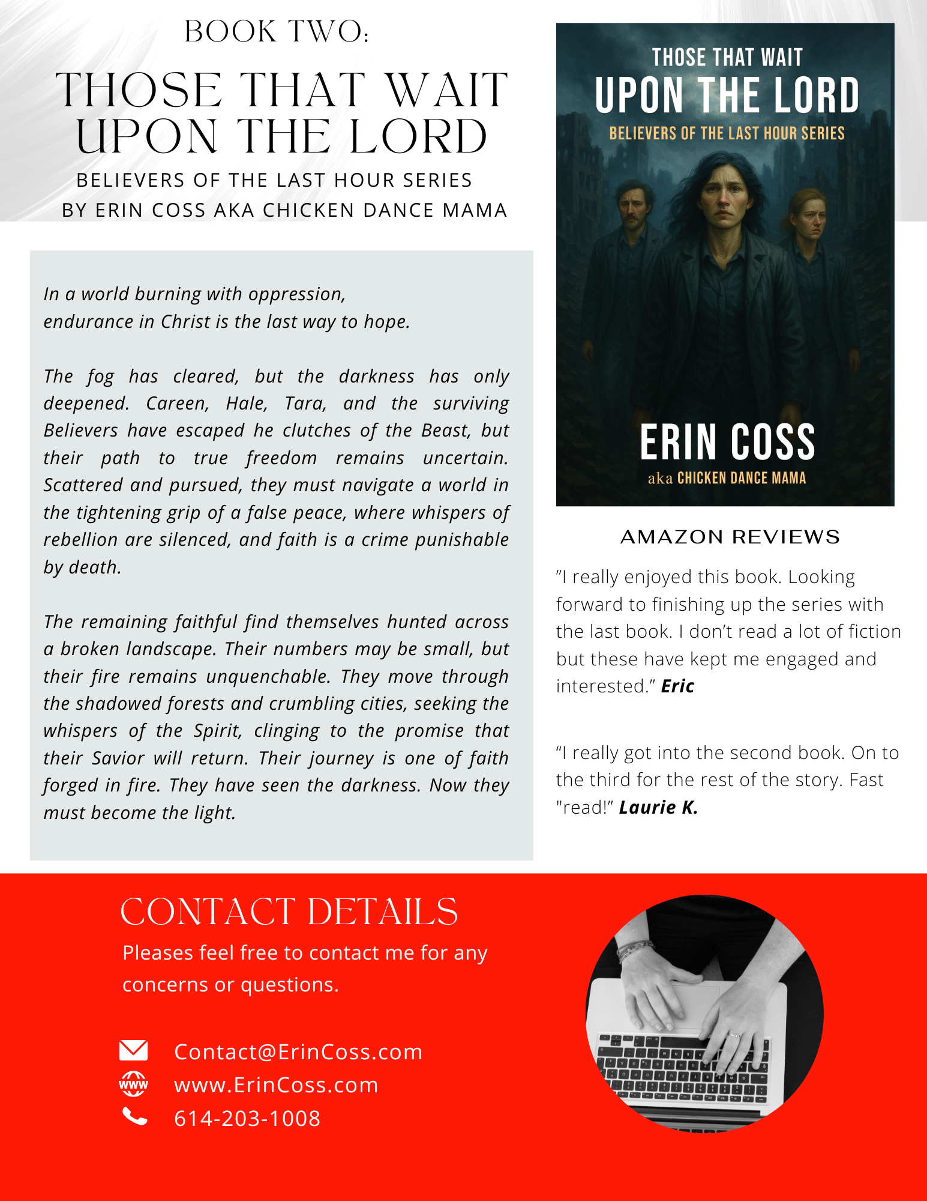

Simple. Unpolished.
But quick and easy to copy and paste.

Erin Coss
Christian Author, Bible Teacher & Speaker
Email: Contact@ErinCoss.com|
Phone: 614-203-1008

Book 2: Those That Wait Upon the Lord
Believers of the Last Hour
By Erin Coss aka The Chicken Dance Mama
In a world burning with oppression,
endurance in Christ is the last way to hope.
The fog has cleared, but the darkness has only deepened. Careen, Hale, Tara, and the surviving Believers have escaped he clutches of the Beast, but their path to true freedom remains uncertain. Scattered and pursued, they must navigate a world in the tightening grip of a false peace, where whispers of rebellion are silenced, and faith is a crime punishable by death.
The remaining faithful find themselves hunted across a broken landscape. Their numbers may be small, but their fire remains unquenchable. They move through the shadowed forests and crumbling cities, seeking the whispers of the Spirit, clinging to the promise that their Savior will return. Their journey is one of faith forged in fire. They have seen the darkness. Now they must become the light.

Amazon Reviews
”I really enjoyed this book. Looking forward to finishing up the series with the last book. I don’t read a lot of fiction but these have kept me engaged and interested.” Eric
“I really got into the second book. On to the third for the rest of the story. Fast "read!” Laurie K.

URL for Book Cover Photo: Those That Wait Upon the Lord
https://erincoss.com/wp-content/uploads/2025/06/Book-2-cover-website.jpg

URL for ErinCoss Website
https://erincoss.com/

