Why Chicken Dance Mama?
Email: Contact@ErinCoss.com

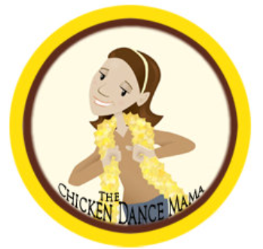

The Chicken Dance Mama
Why Chicken Dance Mama, you ask? Well, it’s simple—I love all things fun and cheesy! One of my absolute favorite things in the world is to go to a wedding and dance the night away to every silly, joyful wedding song—especially the Chicken Dance. I believe life is meant to be enjoyed, and laughter and movement are some of God’s sweetest gifts.
I try to live every day with a cheerful heart, because the Bible says:
“A cheerful heart is good medicine, but a crushed spirit dries up the bones.”
— Proverbs 17:22 (NIV)
The Chicken Dance Mama is my way of celebrating the goodness of God in all things, even the goofy ones! When I praise the Lord, I can’t help but move—I just have to dance. Like David, who danced before the Lord with all his might (2 Samuel 6), I dance with joy, not worried about what anyone thinks. Praise is meant to be expressive, and Scripture encourages us to do just that:
“Let them praise his name with dancing and make music to him with timbrel and harp.”
— Psalm 149:3 (NIV)
And here’s what thrills my heart the most: one day, we’ll all be at the greatest wedding celebration of all time—the marriage supper of the Lamb! The Bible paints a beautiful picture of this in Revelation:
“Let us rejoice and be glad and give him glory! For the wedding of the Lamb has come, and his bride has made herself ready.”
— Revelation 19:7 (NIV)
I say, AMEN! Will you dance with me in praise to our King? I can’t wait to twirl and laugh and celebrate with you at the marriage banquet in heaven. We’ll be singing, dancing the Chicken Dance (and every other cheesy wedding dance), and rejoicing in the presence of Jesus forever and ever!

URL to Chicken Dance Mama Logo
https://erincoss.com/wp-content/uploads/2025/07/Erin-Chicken-Dance-Mama-Logo.png

URL Erin Coss Website
https://erincoss.com/

